Before Webinars / After Webinars (please delete as appropriate) NHI:

The purpose of this form is to find out what your specific symptoms are and how your bowels have been working over the last week. You will be asked to complete this evaluation form before and after participating in our functional gut disorder webinar programme. This will help you, and us, see whether there has been any improvement in your symptoms and bowel habits.

- Do you currently have adequate relief of your gut symptoms? (e.g. are your gut symptoms currently under control?) Yes No

- Using a rating scale of 0-9 please rate your symptoms during the last week by writing in the table below:

Rating Scale:
- None = no symptoms (0)
- Mild = occasional or mild symptoms (1-3)
- Moderate = frequent symptoms that affect some daily activities (4-6)
- Severe = continuous symptoms that affect most daily activities (7-9)

 | Symptom | None | Mild | Moderate | Severe
a | Abdominal pain / discomfort
b | Abdominal bloating / distension
c | Increased flatulence / wind
d | Belching or burping
e | Stomach / abdominal gurgling
f | Urgency to open bowels
g | Feeling of not being able to completely open bowels and pass all stool (incomplete evacuation)
h | Nausea
I | Heartburn
j | Acid regurgitation (reflux)
k | Tiredness / lethargy
l | Overall symptoms

PLEASE TURN OVER

- During the last week, how often did you pass a bowel motion?

Comments:
___________________________________________________________________________________________________________________________________________________________________________________________________________________________________________________________________________________________________________________________________________________________________________________________________________________________________________________________________________________________________________________________________________________________
_________________________________________________

Once a week

Once every 4-6 days

Once every 2-3 days

Once a day

2-3 times a day

4-6 times a day

7 or more times a day

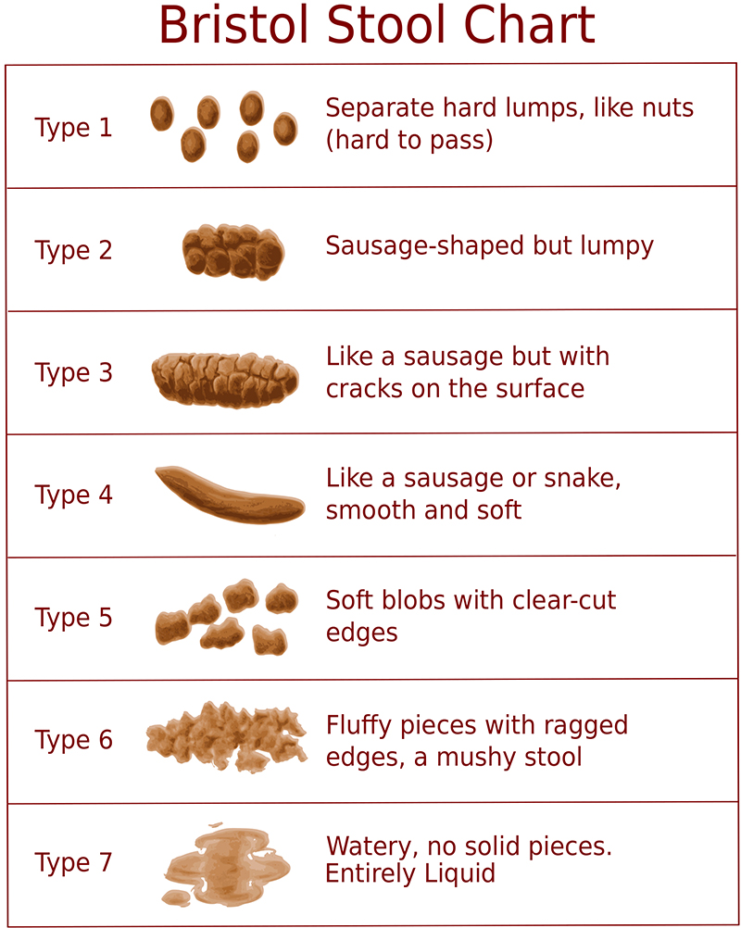
- During the last week, which best describes your bowel motions (stools)? You may mark more than one box.

- Answer this only if you have completed webinar 3: Have you completed the low FODMAP diet: fully partially not at all

Comments:
______________________________________________________________________________________________________________________________________________________________________

